CMPS-218

Fall 2023

Th 6:00 – 9:20 pm

Project

First Petz - Final phase 4

Due Date: 11/16/23

GROUP #: 81 & 11.2

Grade: _

E-mail: Jevaun.lyle@laverne.edu Submitted by: Jevaun Lyle

major: Computer Science concentration: Software

Grade:_

e-mail: erika.ruiz@laverne.edu Submitted by: Erika Ruiz

major: Computer Science concentration: Information Technology

Grade Rubric

| Y  I=N= | 1  .Description=  10%  A lack of   |  | Reduction | | --- | --- | | Poor  descr | -5% | | Cover page | -5% | |  |  |   Legend:  Incomplete No | Y  I  N | 2.  Design=  10%  A lack of   |  | Reduction | | --- | --- | | Site  map | -5% | | WireFrame | -5% | | Screenshot of project location | -5% | | Y  I  N | 3.  Screenshots=  20%  A lack of   |  | Reduction | | --- | --- | | Web  pages | Up to  -10% | | code | Up to  -10% | | Validators | Up to  -10% | | Y  I  N | 4.  Code= 45%  A lack of   |  | reduction | | --- | --- | | references | Up to  –20% | | Highlight changes | Up to  –20% | | Personal | Up to  –20% | | Y  I  N | 5.  Test plan and results = 15%  A lack of   |  | reduction | | --- | --- | | Page  names | Up to  –10% | | Test items | Up to  –10% | | Validator screenshot | Up to  –10% | | Outcome | Up to  –10% | |
| --- | --- | --- | --- | --- | --- | --- | --- | --- | --- | --- | --- | --- | --- | --- | --- | --- | --- | --- | --- | --- | --- | --- | --- | --- | --- | --- | --- | --- | --- | --- | --- | --- | --- | --- | --- | --- | --- | --- | --- | --- | --- | --- | --- | --- | --- | --- | --- | --- | --- | --- | --- |

Implementer 1: Erika Ruiz - Leader

Implementer 2: Jevaun Lyle

Reviewer 1: Patrick Fares - Leader

Reviewer 2: Faith Ripandelli

—------------------------------------------------------------------------------------------------------------------

Group project contribution table

—------------------------------------------------------------------------------------------------------------------

| Component name | Jevaun Lyle  50% | Erika Ruiz  50% | Description |
| --- | --- | --- | --- |
| home.html | 50% | 50% | Both worked together to produce the information and plan for the home page |
| .docx | 80% | 20% | Jevaun did a lot of the .docx, but required help with Table 0 and review |
| contact.html |  | 100% | Erika did the contact page, Jevaun did not help with this page |
| pets.css | 50% | 50% | Both worked on creating the .css and the layout of the website |
| before.html | 50% | 50% | Both worked together on this page to make sure it fit the theme and requirements |
| firstday.html | 0% | 100% | Erika did the contact page, Jevaun did not help with this page |
| mission.html | 100% | 0% | Jevaun did the mission page, Erika helped with formatting, but that's it |
| necessity.html | 0% | 100% | Erika did the contact page, Jevaun did not help with this page |
| resource.html | 100% | 0% | Jevaun did the Resources page, Erika did not help with this page |
| situation.html | 0% | 100% | Erika did the contact page, Jevaun did not help with this page |
| tips.html | 100% | 0% | Jevaun did the Resources page, Erika did not help with this page |
| faq.html | 0% | 100% | Erika did the contact page, Jevaun did not help with this page |

**Home.html**

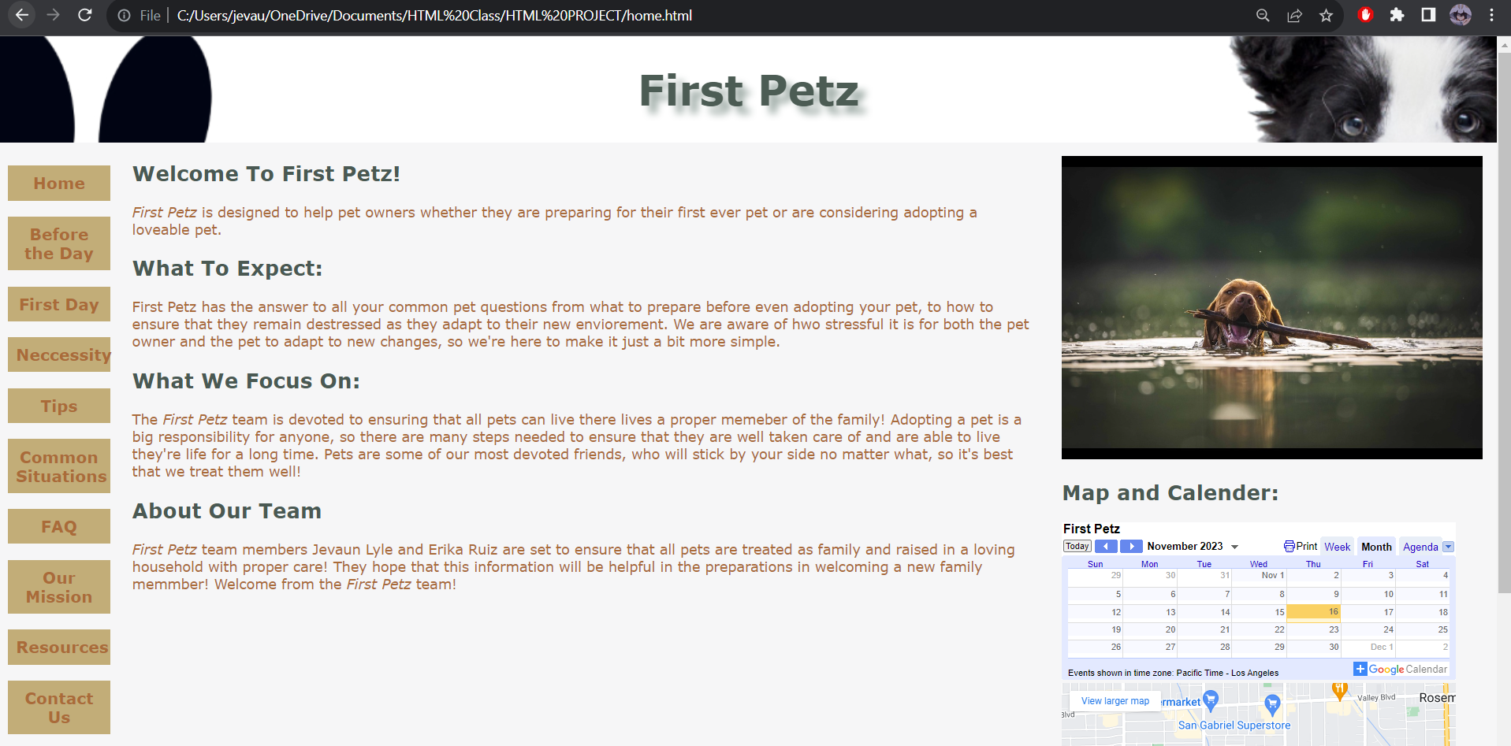

**—------------------------------------------------------------------------------------------------------------------**

**Before.html**

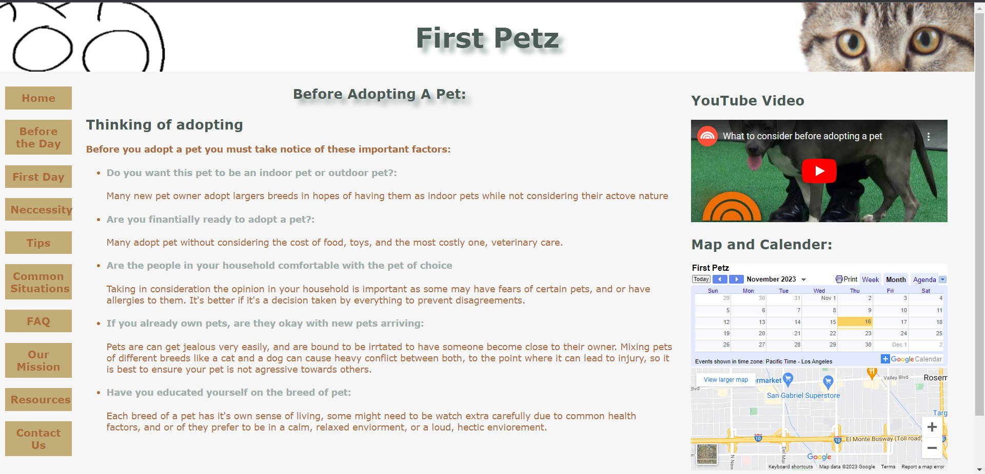

**—------------------------------------------------------------------------------------------------------------------**

**First.html**

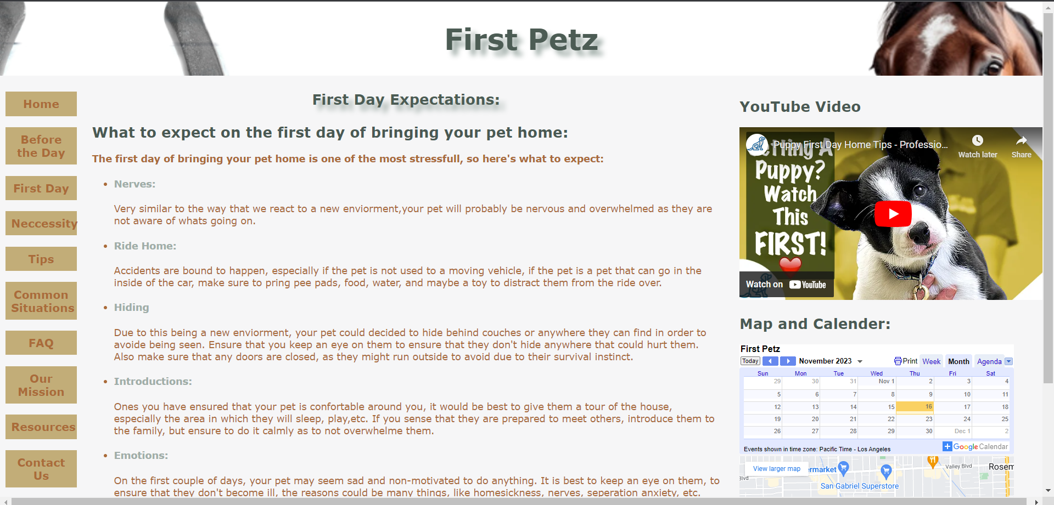

**—------------------------------------------------------------------------------------------------------------------**

**Necessity.html**

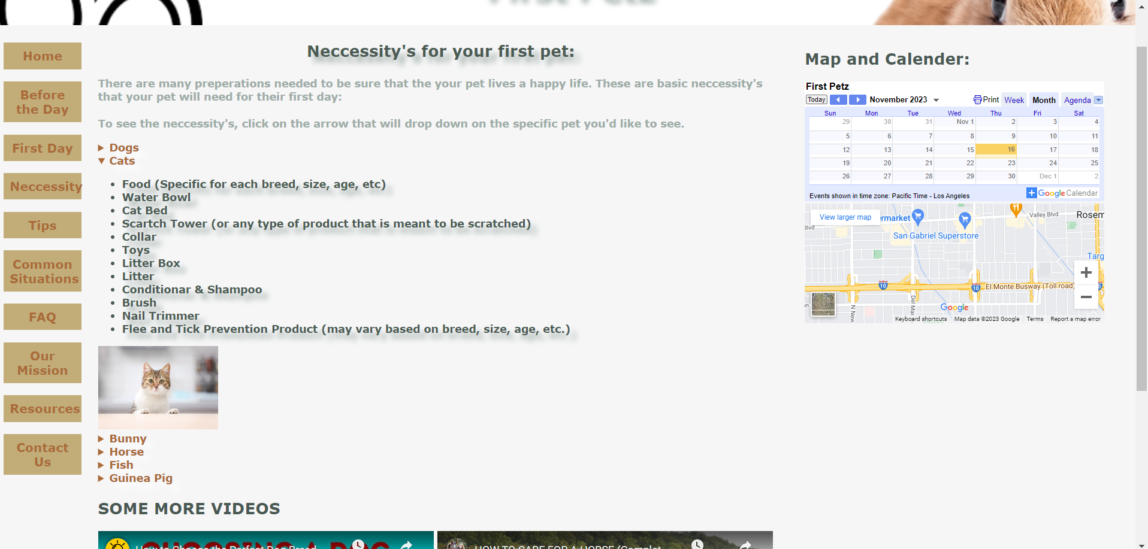

**—------------------------------------------------------------------------------------------------------------------**

**Tips.html**

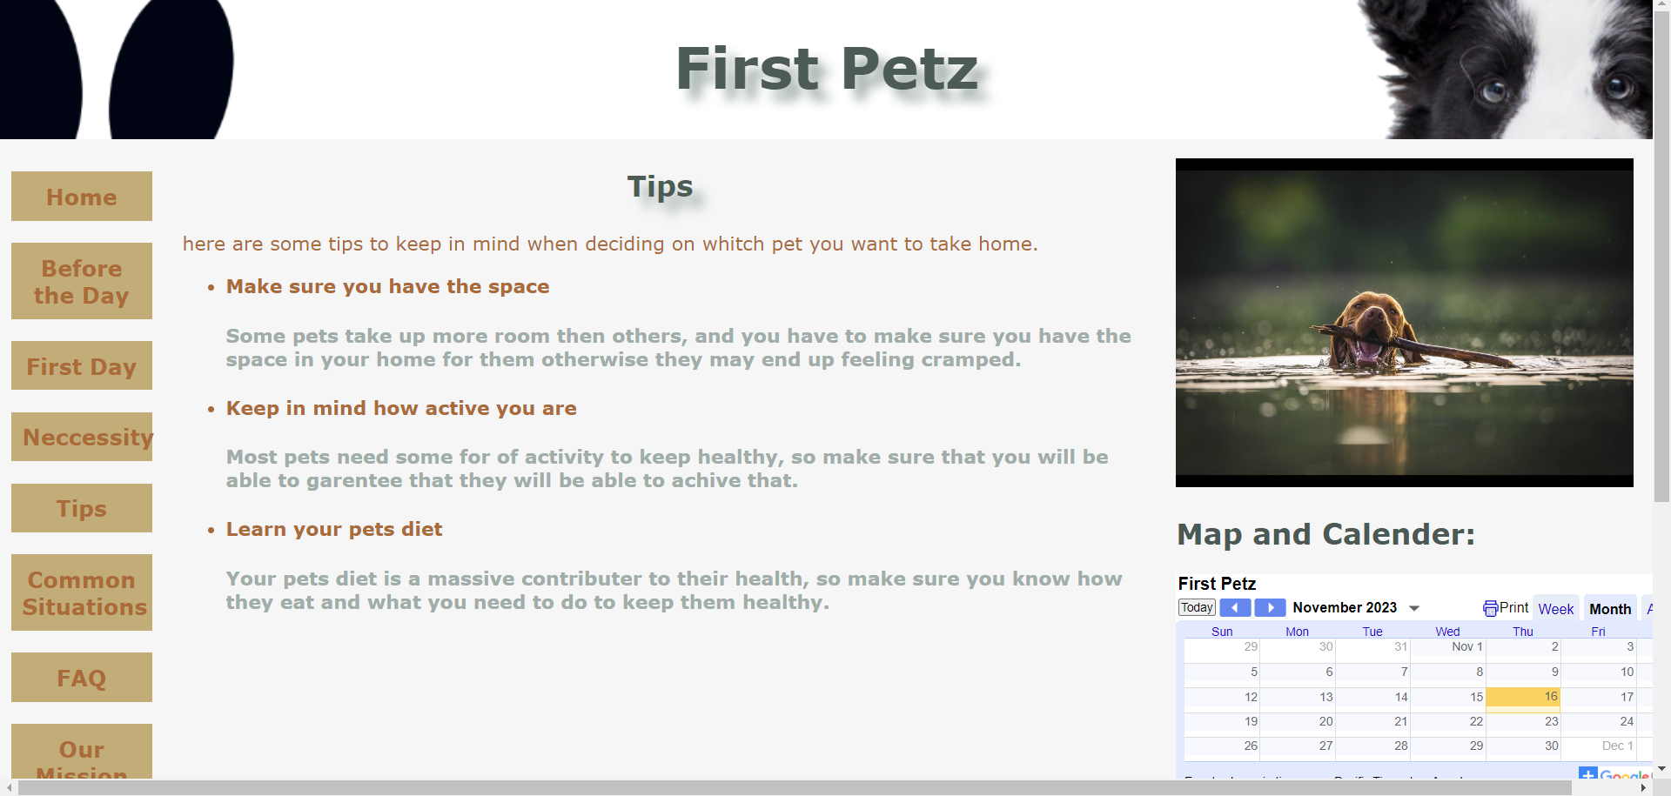

**—------------------------------------------------------------------------------------------------------------------**

**Common.html**

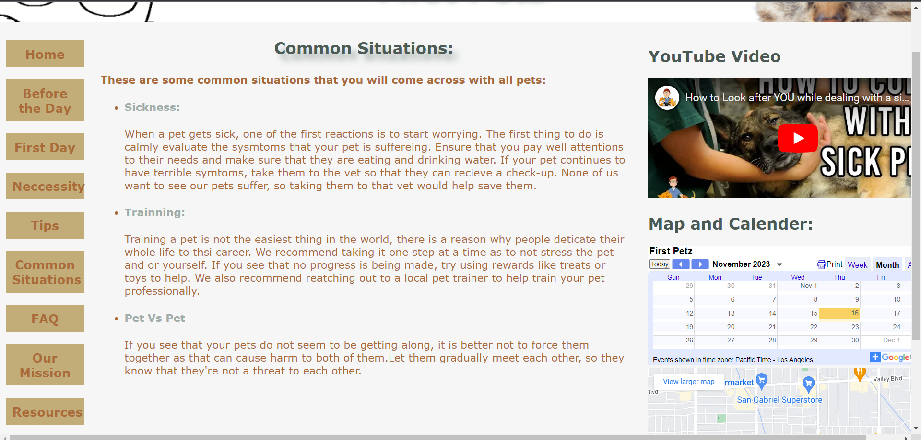

**—------------------------------------------------------------------------------------------------------------------**

**FAQ.html**

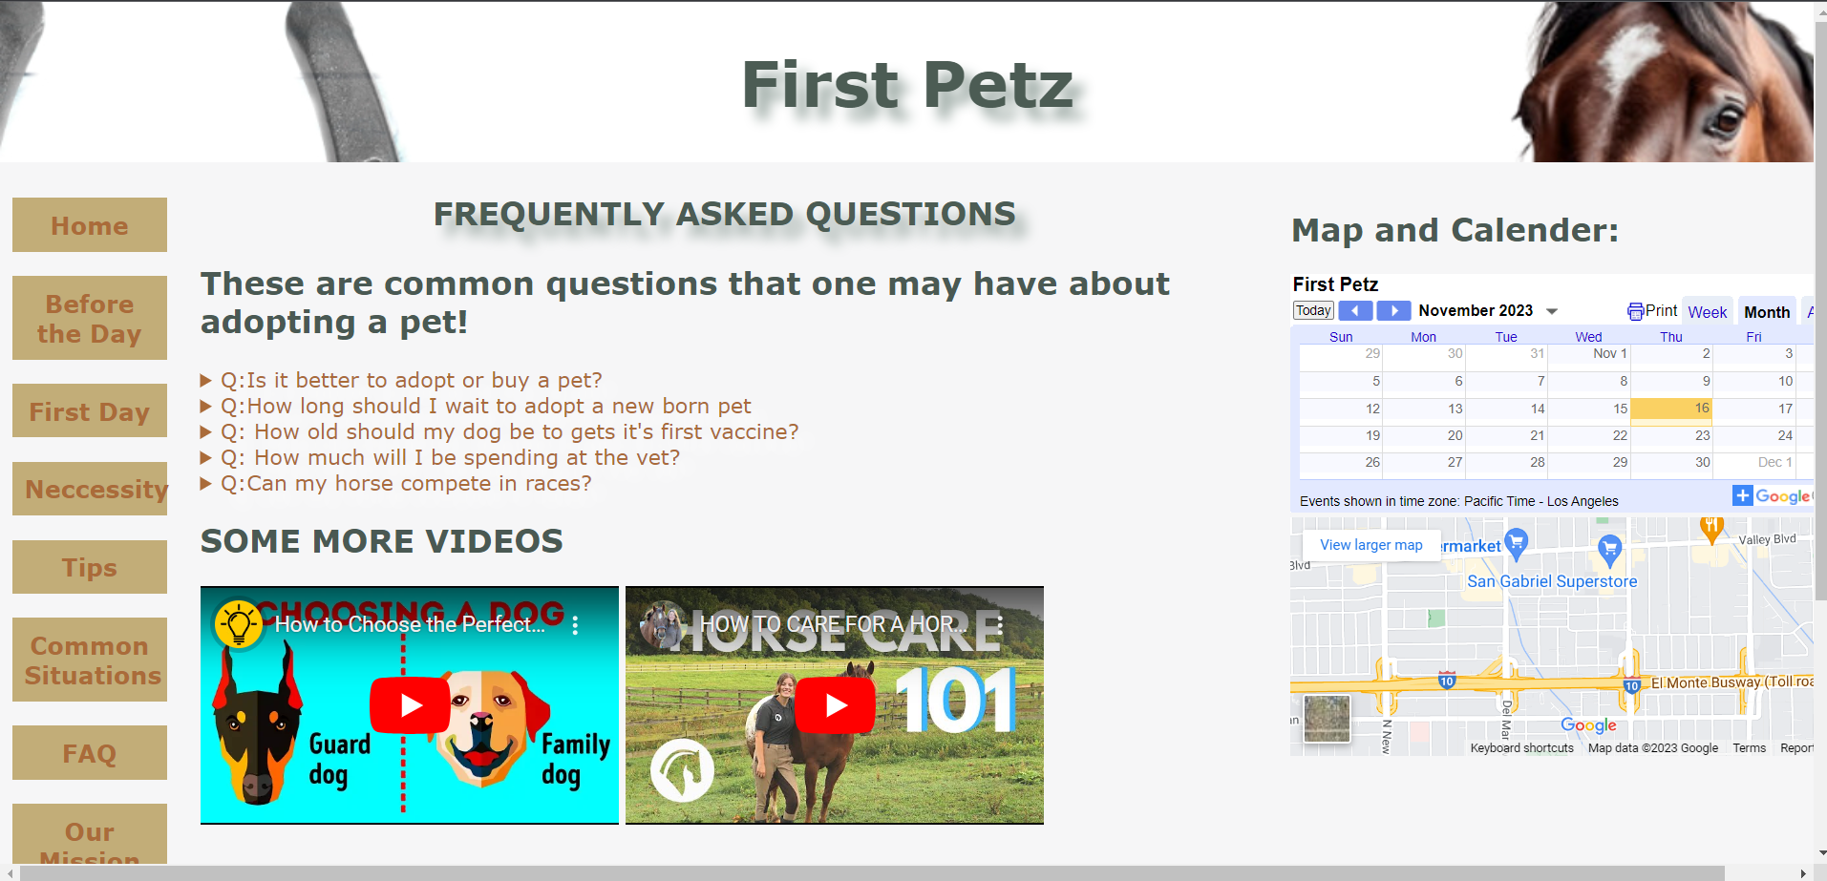

**—------------------------------------------------------------------------------------------------------------------**

**Mission.html**

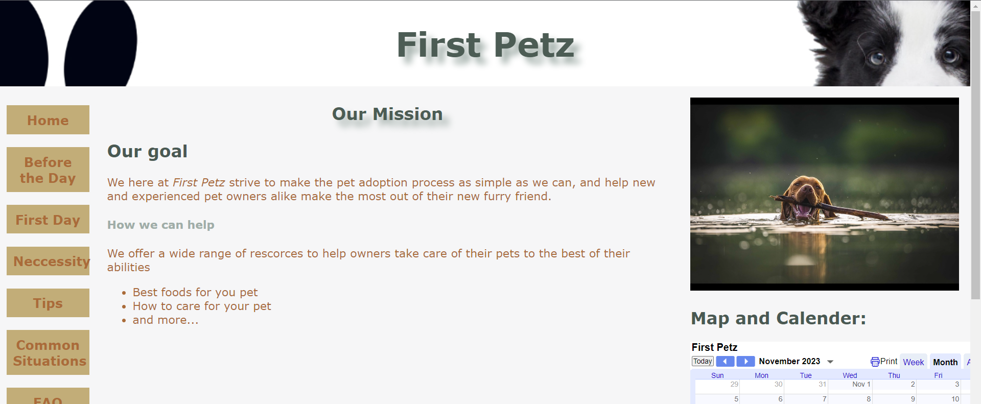

**—------------------------------------------------------------------------------------------------------------------**

**Resources.html**

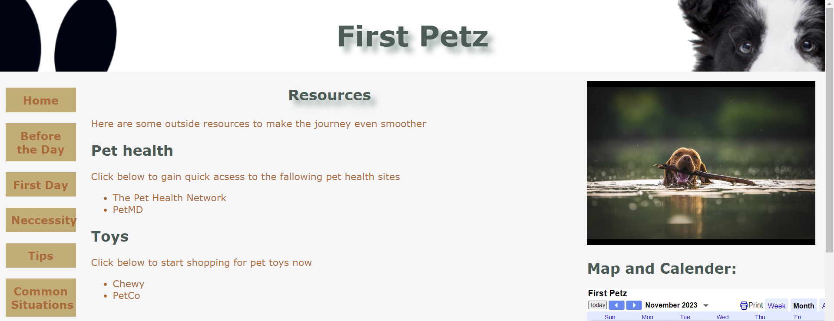

**—------------------------------------------------------------------------------------------------------------------**

**Contact.html**

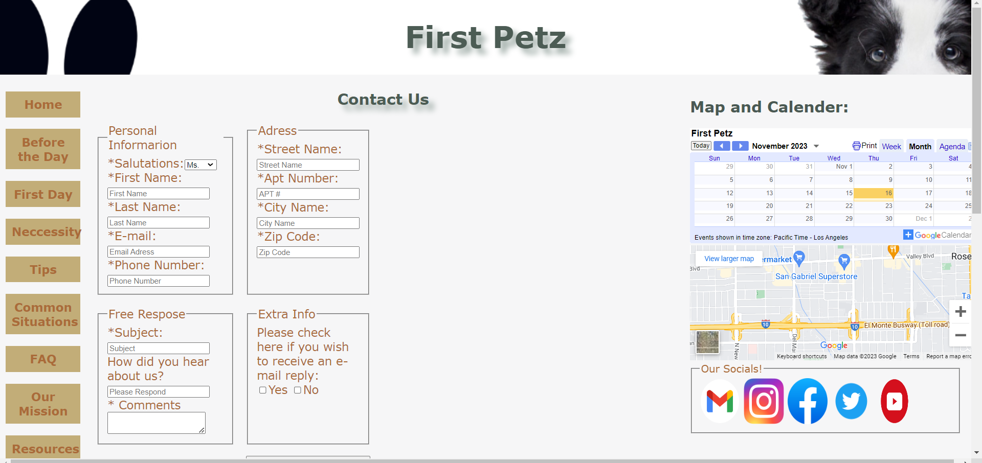

**—------------------------------------------------------------------------------------------------------------------**

**Table 0:**

| **Location –**  **fill it up** | **Reference #** | **Feature** |
| --- | --- | --- |
| **Home.html**  **Before.html**  **Firstday.html**  **Necessity.html**  **Tips.html**  **Situation.html**  **FAQ.html**  **Mission.html**  **Resource.html**  **contact.html**  **.** | **1 PL** | **1. Column Page Layout: Use two-column layout for a single page (ch6 p.258, slides 37-39 and HOP 6.6 p.268, slides 53 ch6 – move the menu to the left side or better two-column layout with grid areas Ch7.7 p.329-331, slides 24-27 ch7 ) or/and preferable three-column (ch7.13-7.14 p.347 -354, HOP 7.10, slides 51-52 ch7) page layout (Responsive Web Design using grid and flex) for your website.** |
| **Home.html**  **Before.html**  **Firstday.html**  **Necessity.html**  **Tips.html**  **Situation.html**  **FAQ.html**  **Mission.html**  **Resource.html**  **contact.htm** | **2 GL** | **2. Grid Layout ch7.11 p.331-333 (HOP 7.5 or HOP 7.6), slides 17-37 ch7 or a Flexible Box Layout with a flexible container ch7.1 p.312-322 (HOP 7.2), slides 4-16 ch7.** |
| **Home.html**  **Before.html**  **Firstday.html**  **Necessity.html**  **Tips.html**  **Situation.html**  **FAQ.html**  **Mission.html**  **Resource.html**  **contact.htm** | **3MQ** | **3. Responsive Grid Layout with Media Queries: ch7.13 (HOP 7.9), slides 46-49.** |
| **Home.html**  **Before.html**  **Firstday.html**  **Necessity.html**  **Tips.html**  **Situation.html**  **FAQ.html**  **Mission.html**  **Resource.html**  **contact.htm** | **4 RI** | **4. Responsive Images: HOP 7.10 – 7.12 p.352-357, slides 50-58 ch7. HOP 7.10 can be your startup website for your final project.** |
| **Home.html**  **Before.html**  **Firstday.html**  **Necessity.html**  **Tips.html**  **Situation.html**  **FAQ.html**  **Mission.html**  **Resource.html**  **contact.htm** | **5 NL** | **5. Navigation Layout: Use CSS Vertical or Horizontal Navigation Layout Using Unordered List (slides 42-44 ch6.7 – 6.8 or p.260-265) and CSS imitation buttons for navigation with the hover feature (see** [**http://classes.jgspectrum.com/classes/218_F23/examples/ch6/navbuttons.html**](http://classes.jgspectrum.com/classes/218_F23/examples/ch6/navbuttons.html)**, ch6.9 p.267 and slide 50-51 ch6).** |
| **Resource.html**  **Tips.html** | **6 ND** | **6. Interactive Navigation with a horizontal or vertical Drop Down Menu: Have at least a menu with 2 - 3 subpages (HOP 11.4 p.503-504, slide 46 ch11. Solutions:** [**http://classes.jgspectrum.com/classes/218_F23/examples/ch11/horizontal_menu/index_1.html**](http://classes.jgspectrum.com/classes/218_F23/examples/ch11/horizontal_menu/index_1.html) **and** [**http://classes.jgspectrum.com/classes/218_F23/examples/ch11/vertical_menu/index_1.html**](http://classes.jgspectrum.com/classes/218_F23/examples/ch11/vertical_menu/index_1.html)**.** |
| **Home.html**  **Before.html**  **Firstday.html**  **Necessity.html**  **Tips.html**  **Situation.html**  **FAQ.html**  **Mission.html**  **Resource.html**  **contact.htm** | **7 TN** | **7. Text-Based Navigation Bar: Use the text-based navigation bar at the bottom of your pages (e.g. HOP 4.4 ch4.3 p.150, slides 48, 53 ch4).** |
| **Home.html**  **Before.html**  **Firstday.html**  **Necessity.html**  **Tips.html**  **Situation.html**  **FAQ.html**  **Mission.html**  **Resource.html**  **contact.htm** | **8 NP** | **8. Navigation with Pseudo-Classes: Implement the :link, :visited, and :hover pseudo-classes (HOP 6.6 ch6.9 p.270, slide 53 ch6 and HOP 7.10, slide 52 ch7).** |
| **Home.html**  **Before.html**  **Firstday.html**  **Necessity.html**  **Tips.html**  **Situation.html**  **FAQ.html**  **Mission.html**  **Resource.html**  **contact.htm** | **9 MC** | **9. Menu Color Change using Transition: HOP 11.6 p.507, slide 51 ch11.** |
| **Necessity.html**  **FAQ.html** | **10 DS** | **10. Details and Summary Elements: Configure a page with summaries, HOP 11.9 p.515-516, slides 61-62 ch11.** |
| **Hygiene.html**  **food.html** | **11 BC** | **11. Breadcrumb Trails: Use breadcrumb trails (slide 3 ch5 part II or p.224 ch5.9). Implement breadcrumbs for submenus.** |
| **pets.css** | **12 SF** | **12. Style FORM with CSS: (see expanded ch9. Project in Assignment.doc or WEEK 6 in Assignment.OL.doc). Configure the form with HTML 5 using at least 10 input types (example: <input type=”email” >), set accesskey, tabindex, fieldset with legend, required and placeholder attributes and values (HOP 9.8 p.448-450). All form controls should be vertically aligned. The CSS is listed on ch9. p.437, slide 92 or use chapter 9 project css. Use** [**https://webdevbasics.net/scripts/demo.php**](https://webdevbasics.net/scripts/demo.php) **to test it.**  **You may submit the form to an e-mail of the business owner or use** [**http://www.formmail.com/**](http://www.formmail.com/) **- you may signup for our free trial and they will even provide you with HTML source you can copy and paste onto your web site to have a contact form up.** |
| **main.css,**  **pets.css_print.css** | **13 ES** | **13. External Style Sheets: Use two different external style sheets for your browser and printer (HOP 6.8 p.273-4, slides 62-63 ch.6). You need to specify names on your final report cover and on your 1st presentation slide.** |
| **Home.html**  **Before.html**  **Firstday.html**  **Necessity.html**  **Tips.html**  **Situation.html**  **FAQ.html**  **Mission.html**  **Resource.html**  **contact.htm** | **14 IF** | **14. i-frames: Embed another Web page using i-frames (such as News, you tube video, Google calendar etc.) in one of your Web pages (slides 34-39 ch13 or ch13.10 p.578-580).** |
| **contact.html** | **15 MT** | **15. Meta Tags: Add keywords and description meta tags to each page (slides 12-14 ch13, p.568).** |
| **foods.html**  **hygiene.html** | **16 RQ** | **16. Quick Response Code ch13.9 p.574, slide 31 ch13: Generate the QR (Quick Response) Code from** [**http://www.qrstuff.com**](http://www.qrstuff.com/) **for your website and incorporate QR in your Website.** |
| **Home.html**  **Before.html**  **Firstday.html**  **Necessity.html**  **Tips.html**  **Situation.html**  **FAQ.html**  **Mission.html**  **Resource.html**  **contact.htm** | **,17 BV** | **17. My e-mail and best viewed: Include your email(s) in your footer and specify as follows: The site best viewed with the latest versions (specify versions) of Chrome, Firefox, or Edge. You may say e.g. “*The site best viewed* in Firefox or Chrome” as well.** |
| **food.html** | **18 FL** | **18. Table with CSS: Include a Table on your web page (HOP 8.4 p.397, slides 59 – 61 ch8).** |
| **Home.html**  **Before.html**  **Firstday.html**  **Necessity.html**  **Tips.html**  **Situation.html**  **FAQ.html**  **Mission.html**  **Resource.html**  **contact.htm** | **19 GC** | **19. Add a** [**Google calendar**](https://support.google.com/calendar/answer/41207?hl=en) **– click it.** |
| **Home.html**  **Before.html**  **Firstday.html**  **Necessity.html**  **Tips.html**  **Situation.html**  **FAQ.html**  **Mission.html**  **Resource.html**  **contact.htm** | **20 GM** | **20. Add a** [**Google map.**](https://embedgooglemaps.com/en/)  **Define two hotspots (e.g. 2 business locations) – see slides 19-22 ch4 or see ch4/map.html.** |
| **imagegallery.html** | **21 LI** | **21. Add the mouse over a thumbnail and the larger version of that image is gradually displayed with a caption (HOP 11.7 p.508-510, slide 55-56).** |
| **contact.html** | **22 SM** | **22. Add links to social media:**  **i. Social Networking (at least 5 of them)**  **1. Facebook**  **2. LinkedIn**  **3. Twitter**  **4. YouTube**  **5. Instagram**  **6. Google+**  **ii. You may add social bookmarking services**  **iii. You may add Blogs & RSS feeds - gives visitors a reason to check back regularly.** |
| **Before.html**  **Firstday.html**  **Necessity.html**  **contact.htm** | **26** **V**      **23 MI** | **23. Add media and interactivity - you may include the background sound or any podcast: see audio controls as is shown in HOP 11.2, slide 20 (or case study chapter 11) with CSS audio {display: block; margin-top: 1em;}**  **or add video controls shown on p.501 – HOP 11.3, slides 39-40. Follow the following instructions:**  **a. Use the youtube site to find the video you want.**  **b. Click the 'Share' button below the video.**  **c. Click the 'Embed' button next to the link they show you.**  **d. Copy the iframe code given and paste it into the html of your web page.** |
| **Phase_4+FirstPetz+Lyle+Ruiz.docx** | **24** | **24. Highlight together with your comments (use a yellow color) elements of code which you had to add or modify in addition to what you copied from the textbook/lecture notes or samples.**  **Example for HTML:**  **<!-- 11/15/22 JSmith NEW 3L: define the text based navigation**  **highlight a new or modified or replaced code in your hard copy**  **highlight a new or modified or replaced code in your hard copy**  **highlight a new or modified or replaced code in your hard copy**  **or**  **<p><span class=”resort”>Pacific Trails Resort</span><!--** |
| **Phase_4+FirstPetz+Lyle+Ruiz.docx** | **25** | **25. All CSS group code lines should have comments using /* and */, for example**  **/* define a tablet device viewport size */**  **For example: file.css**  **/* 11/15/22 JSmith NEW 4L: Configure the left column navigation area */**  **nav { text-align: center;**  **float: left;**  **width: 100px;**  **font-weight: bold;**  **padding-top: 10px;**  **}** |
| **Phase_4+FirstPetz+Lyle+Ruiz.docx** | **26** | **26. Highlight in light blue all direct CSS references you use in the body of each web page (for example <div id="gallery"> ).** |
| **Phase_4+FirstPetz+Lyle+Ruiz.docx** | **27** | **27. Circle each HTML, CSS code fragment and each web page screenshot in red with the name corresponding to items 1 – 23 above.** |
|  | **28 GS** | **28. You may add a** [**Google search**](https://support.google.com/customsearch/answer/2630969?hl=en) **- extra** |
|  | **29 CA** | **29. You may add a** [**reCAPTCHA**](https://developers.google.com/recaptcha/intro) **- extra** |
|  | **30 GT** | **30. You may include a Google Translator** [**https://wcmshelp.ucsc.edu/advanced/google-translate.html**](https://wcmshelp.ucsc.edu/advanced/google-translate.html) **- extra** |
|  | **31 IR** | **31. You may include an Image Rotation:** [**http://jquery.malsup.com/cycle/**](http://jquery.malsup.com/cycle/) **- extra** |

**—------------------------------------------------------------------------------------------------------------------**

**Website Map**

**—------------------------------------------------------------------------------------------------------------------**

